Given a binary tree, return the sum of values of nodes with even-valued grandparent.  (A *grandparent* of a node is the parent of its parent, if it exists.)

If there are no nodes with an even-valued grandparent, return 0.

**Example 1:**

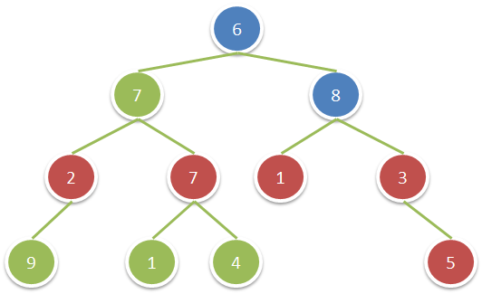

**Input:** root = [6,7,8,2,7,1,3,9,null,1,4,null,null,null,5]

**Output:** 18

**Explanation:** The red nodes are the nodes with even-value grandparent while the blue nodes are the even-value grandparents.

**Constraints:**

* The number of nodes in the tree is between 1 and 10^4.
* The value of nodes is between 1 and 100.